**Mobile/Dynamic Bus Faire Calculation**

* Users getting on/off the bus
* Is charged according to the distance he travels (minimized/optimal street distance)
* Map: Visualize the amount of money a bus earned on parts of his route, how many people are on it and get on/off; where the most important bus routes are
* Use existing bus data
* Randomly generate passengers
* Option: Compare our system to the existing, fixed price system
* Option: current CO2 consumption/areas

USE CASE:

Charge Passengers according to the travelled distance from start to endpoint

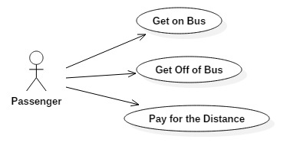

|  |  |
| --- | --- |
| Name of the Use Case | Get on Bus |
| Summary: | User gets on the bus to start his journey |
| Normal procedure of events: | 1. User enters the bus 2. Application recognizes that specific user hopped on the bus 3. Application saves the journey starting point and time |
| Alternative procedure of events: |  |
| Exceptions: | The current position of the user/bus cannot be determined |
| Trigger: | User getting on the bus |
| Assumptions: | - |
| Preconditions: | - |
| Postconditions: | User leaves the bus at some time in the future |
| Author: | Kathrin Kefer |
| Date: | 22.07.2016 |

|  |  |
| --- | --- |
| Name of the Use Case | Get off the Bus |
| Summary: | User gets off of the bus to end his journey |
| Normal procedure of events: | 1. User leaves the bus 2. Application recognizes that specific user hopped off the bus 3. Application saves the journey end point and time |
| Alternative procedure of events: |  |
| Exceptions: | The current position of the user/bus cannot be determined |
| Trigger: | User getting off the bus |
| Assumptions: | - |
| Preconditions: | User entered the bus |
| Postconditions: | - |
| Author: | Kathrin Kefer |
| Date: | 22.07.2016 |

|  |  |
| --- | --- |
| Name of the Use Case | Calculate the bus faire dynamically |
| Summary: | User pays for the distance he travelled with the bus |
| Normal procedure of events: | 1. Application calculates the transfer faire dynamically based on the stored journey start and end points 2. Application charges the user the calculated faire |
| Alternative procedure of events: |  |
| Exceptions: | There is not enough money on the user’s credit card available, the travelled distance cannot be calculated |
| Trigger: | User getting off the bus |
| Assumptions: | There is enough money on the users credit card to pay for the transfer |
| Preconditions: | User left the bus |
| Postconditions: | The paying transaction is successful |
| Author: | Kathrin Kefer |
| Date: | 22.07.2016 |